I THINK I FOUND THE SOLUTION TO THIS PROBLEM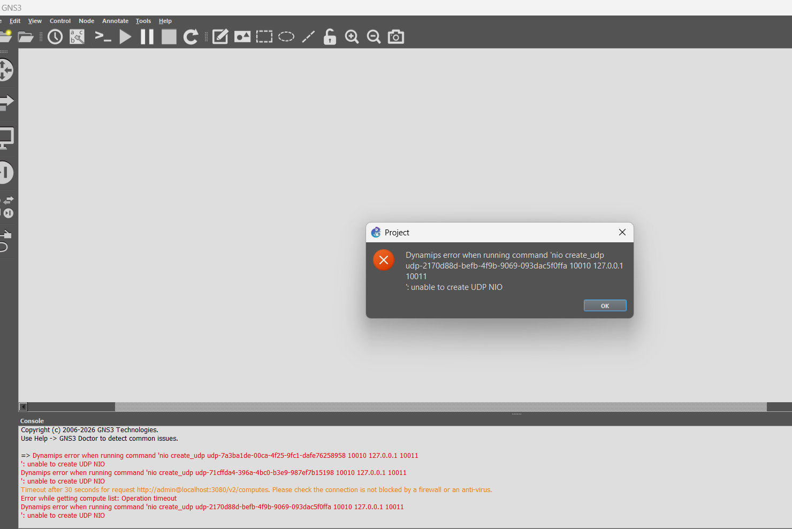
You have to change the UDP ports : edit -> preferences -> server
And change UDP tunneling range like I did from 30000 to 40000
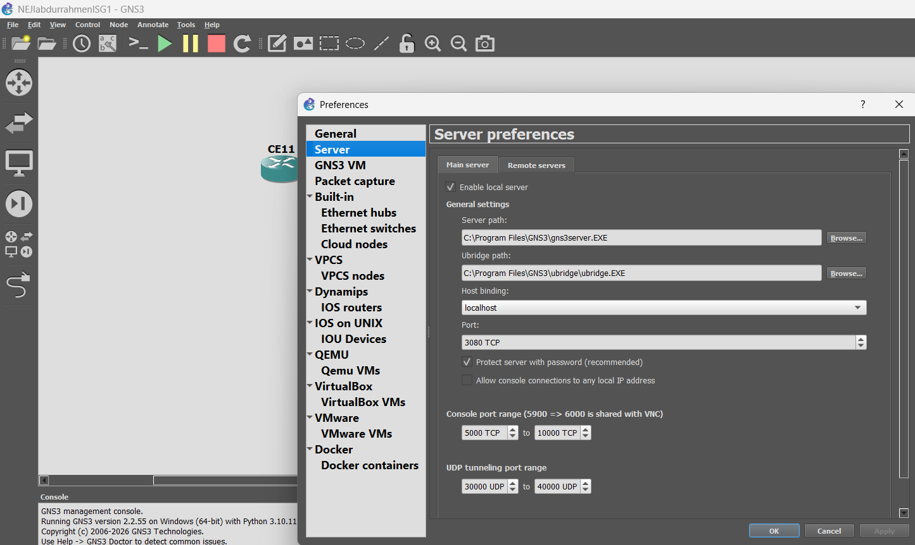
I also started saving every new project with another name, I am not taking any more chance you have no idea how many projects I had to redo.

GNS3 require good pc to work properly otherwise you may run into stupid trouble
You need router version that works to work
You need to be connected to the internet to make the project, otherwise a lot of stuff aren’t going to work. (maybe this might be wrong)
You should put the routers and the connections before you start the routers for best result (I think)

Whatever you do, do not close these tabs, it will literally crash your project…
You won’t be able to open it again, You will be sad, you may even cry
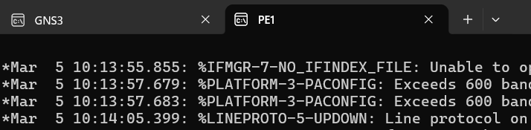
How to close the project:
first copy run start
Then click stop all nodes
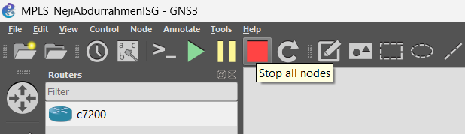
Then wait a bit until every node is red
Then you can safely click quit from file
